Assignment 1

You have been asked to:

● Setup Ansible cluster with 3 nodes

● On slave1 install java

● On slave 2 install MySQL-server

Do the above tasks using Ansible playbooks

* **Created 3 instances i.e., Master, Slave1 and Slave2**

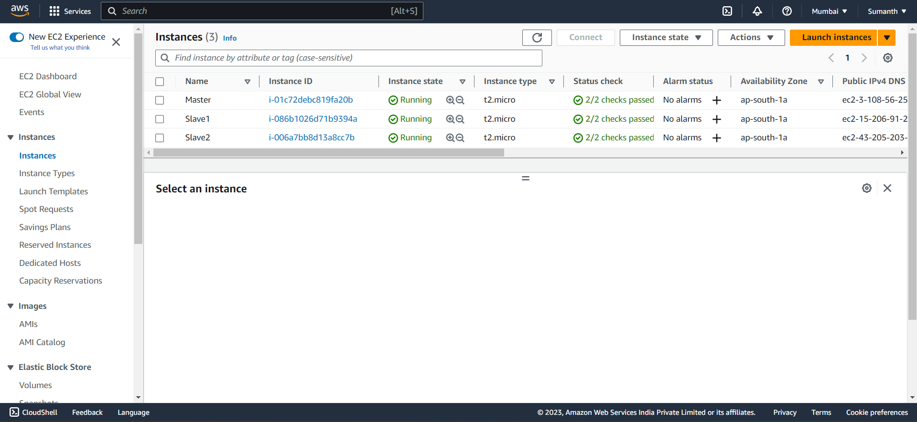

* **Installed Ansible on my Master using the below commands**

sudo apt install software-properties-common

sudo add-apt-repository --yes --update ppa:ansible/ansible

sudo apt install ansible

* **Specified playbook in master instance**

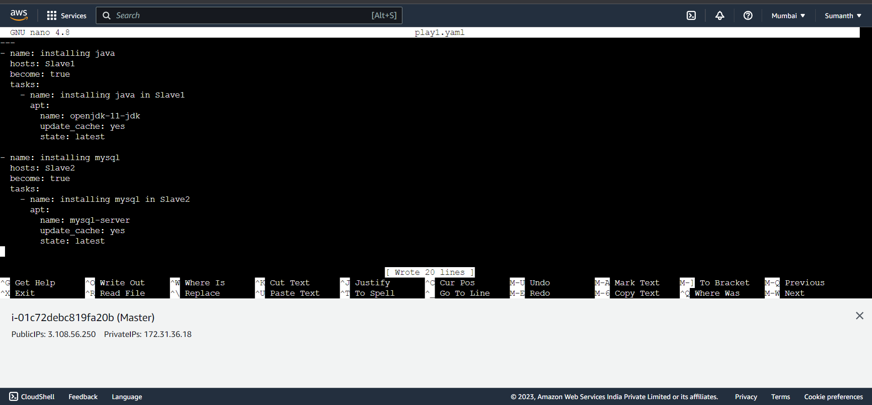

* Installed Java in Slave1 and MySQL-server in Slave2

